**Covid-19 Detection System using Chest X-Ray**

Pritam Mondal, Arya Panja and Vedant Sikdar

Dr. Chandra Mouliswaran S

School of Information Technology & Engineering

Department of Computer Application

Vellore Institute of Technology, Vellore – 632014, Tamil Nadu, India.

E-mail: chandramouliswaran@vit.ac.in

**Abstract**

Covid-19 has changed our entire world having been a total menace. In February 2020, the World Health Organization (WHO) proclaimed it to be pandemic. It was first believed to have emerged from China in December 2019. Covid had a disastrous impact on the entire mankind killing more than half a billion people worldwide. Even developed nations with well-established medical infrastructure were shocked; unable to stop the loss of human life. To date, RTPCR and other tests have been used to identify the illness. However, they take a little longer. Therefore, in order to construct required models utilising the CT scan and chest X-ray images of the affected ones, scientists are applying AI-based approaches. Their objective is to accurately and promptly diagnose the illness. This project is centred on developing an improved model in order to instantly detect covid-19 using chest X-rays with maximum perfection. In this work, a novel 16-layer CNN model is suggested. In our experiment, we used two datasets, the first of which had 224 chest x-ray images and the second of which contained 4626 chest x-ray images. The model's patient categorization accuracy is quite up to the mark.

**Key Words**

Covid-19; Chest X-ray images; Convolutional neural networks; CNN; Deep learning.

**Introduction**

Corona Virus Disease was initially identified as an epidemic in late 2019 in Wuhan, China. It spread like a wildfire across the entire world, and in 2020, the WHO declared it to be a pandemic. Since then, human society has suffered great damage and has completely collapsed. The government enacted security measures like quarantine, house isolation, and lockdown to stop the disease's spread. Gradually, the economy weakened, the public healthcare system failed, and thousands of people died. Finding a vaccinated cure or another treatment is challenging because of this fast mutation. The virus originally infected people's respiratory tracts through droplets and later damaged lungs, producing acute pneumonia. The symptoms can range from moderate to severe, and many infected people show no symptoms at all, turning into silent epicentres. Chest X-rays of pneumonic patients show mottling and ground-glass opacity. Huge patient data sets may be analysed using artificial intelligence to enhance patient management and decision-making. Deep learning-based approaches, which are based on artificial intelligence, are frequently used. Covid-19 can be detected primarily using three different techniques: RTPCR, CXR, and CT scan. Despite the accuracy of the RTPCR test, it takes a long time. The CXR and CTS pictures, on the other hand, diagnose diseases more quickly and are used to examine their aftereffects. Convolutional neural networks (CNN) have proven to be effective models for analysing medical images. CNN accepts an image as input. It then has one or more convolutional (Conv) layers where it applies numerous filters to the input picture to conduct convolution on the image to create a feature map. The function of one or more pooling layers is to down-sample the enormous features produced. One-dimensional features are produced using a flatten layer and sent into one or more fully connected layers before being concatenated into a single output layer for the classification result. Multiple dropout layers may be employed to prevent the model from fitting the data too closely during training. CNN uses a hierarchy of layers that resembles the human brain in order to learn macro characteristics from the data acquired from the layer before.

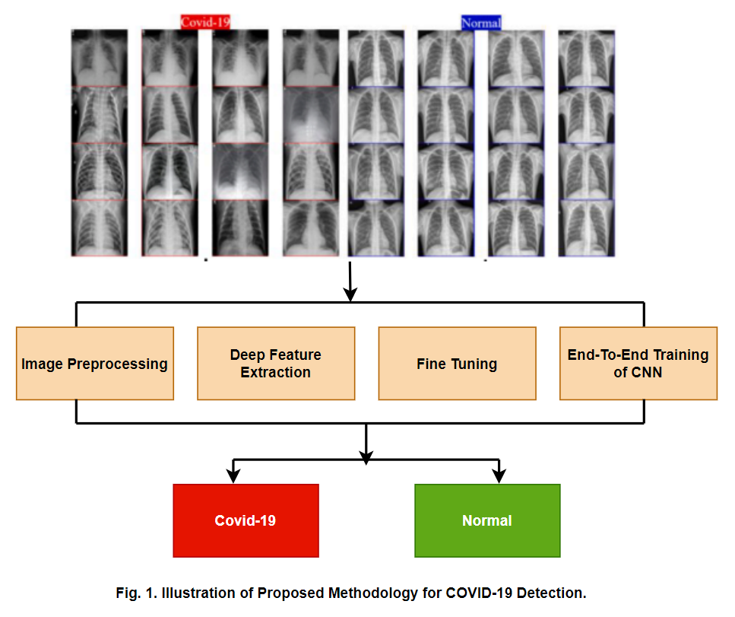

Fig. 1 Outline of suggested approach to detect Covid-19.

**Related work**

In this section, we look at the literature research done over the previous three years on CNN's usage in Covid-19 detection. For the purpose of detecting Covid-19, A.M. Ismael et al. (A.M. Ismael et al., 2021) used 224 x 224 scaled chest X-ray images. Pre-trained CNN models like VGG (16/19) and ResNet (18/50/101), are used in a transfer learning technique. Features from earlier trained networks are supplied into the SVM using kernels that are linear, quadratic, cubic, and gaussian. With respect to features derived using ResNet18/50/101 and VGG16/19, the model attained average accuracy in the range of 85% to 90%. The best average accuracy is provided by the cubic kernel (90.3%). For the trial, 180 and 200 chest X-ray photographs of Covid-19 and healthy subjects, respectively, were employed. All models were fine-tuned, and ResNet50 provided 92.63% accuracy. Lastly, a CNN model (21-layeres) is trained, consisting of 1 input layer, 5 convolutional layers, 5 ReLU layers, 5 batch normalisation layers, 2 pooling layers, 1 fully connected layer, 1 SoftMax layer, and 1 output layer. With a starting learning rate of 0.001, the stochastic gradient descent optimizer with momentum (SGDM) is applied. After 11400 epochs, the obtained training accuracy is 91.58%. As a result of their extensive image training, CNN that has already been trained displays improved accuracy, according to the data. In addition, eight image texture features are considered for comparison purposes which are QLRBP, Frequency Decoded LBP, BSIF, LPQ, CENTRIST, LBP, BGP and PHOG. All kernels except Gaussian produced the best accuracy, 90.5 percent, from BSIF. In several situations, CNN outperformed it; for instance, ResNet + SVM produced an accuracy of 94.7%.

For Covid-19 detection, H. Panwar et al. (H. Panwar et al., 2020) used a grad-CAM based colour visualisation method with CNN. The suggested model is a 19 Convolutional-ReLU-MaxPooling layer, 27-layer CNN. Gradient Weighted Activation Class Mapping (Grad CAM) was developed by Selvaraju et al. to explain the CNN. Grad CAM is used at the final convolutional layer after the label prediction to view the output. The algorithm that is suggested does binary classification. As the initial base model for transfer learning, VGG19 was trained on 1,41,97,122 pictures and the suggested model is applied with the pretrained weights. Covid 19 vs. normal x-ray image, Covid-19 vs. pneumonia, and Covid-19 vs. non Covid19 dataset are 3 separate classification tests that are performed. In percentage terms the accuracy, sensitivity and specify are 89.47, 76.19, and 97.22 respectively. Using CXR and CTS images, E. Hussain et al. suggested a CNN (22 Layers) to identify Covid. The suggested CNN model "CoroDet" is capable of diagnosing three different types of pneumonia, covid and normal. 18 (Convolutional + Maxpooling) ReLU layers, including 2 dense, 1 flat, and 1 leaky, were employed in the model. Training is conducted with batch sizes of 10 and 50 epoch with a learning rate of 1/10000. The dataset was put together from CXR and CTS pictures from eight separate standard datasets. For their trial, they employed 2843 Covid-19 photos, 1439 images with pneumonia and 3108 normal images. Fivefold cross validation is performed once again on the training data. For the 2-class classification, 3 class classification, and 4 class classification examples, the accuracy levels were 99.1, 94.2, and 91.2, respectively. For each class in each classification task, the F1-score, Recall, and Precision are assessed, and the results are determined to be between 86.15 and 97.51 percent.

A 46 layered CNN was suggested by S. Chakraborty et al. (S. Chakraborty et al.,2022) to detect COVID-19 using patient CXR. Max-pooling, convolution, polling, hidden, dropout, and SoftMax layers were present in the model. It classifies the dataset into three different classes. The pulmonary contour mask and FCDenseNet103 segmentation algorithm are used to get the region of interest, or the lung region, from the chest x-ray image. ResNet18’s trained weight values are utilised in the suggested model to implement transfer learning. To tackle the vanishing gradient problem, skipping is used. The dataset includes of a collection of Covid19, Pneumonia, and Normal patients' 2143, 3674, and 4223 224x224 CXR pictures. The dataset is extended from 10400 to 16574 photos by flipping, enlarging, and rotating the images. SGD optimizer is used to run the training with 13251 images. The model was accurate at 96.43%. For covid19, pneumonia, and normal pictures, the AUC was calculated to be 0.99, 0.97, and 0.98, respectively.

Using CXR pictures, V. Madaan et al. (V. Madaan et al.,2021) built a CNN model for the detection of covid19. The suggested model has 3 max pooling layers, 1 ReLU layer, and 4 conv layers respectively. The experiment uses 196 covid and 196 non-Covid-19 CXR frontal pictures. CXRs were enlarged to 224x224x3 in order to reduce noise. Shearing, zooming, and horizontal flipping were also utilised. Adam optimizer, 50 iterations, a learning rate of 0.001, and a batch size of 32 were employed in the training. Two MaxPooling size and stride settings are used to test three different CNN versions. The finest accuracy is 98.44%. R. Tawsifur et al. (R. Tawsifur et al.,2021) investigated the impact of picture augmentation and segmentation on the COVID-19 detection accuracy using CXR. The initial dataset had 18479 CXR images, including 3616 Covid-19 photos, 8851 healthy images, and 6012 non-Covid images. The detection performance of five image enhancement algorithms—namely, complement, histogram equalisation, contrast limiting adaptive HE, gamma correction and balanced contrast enhancement—was examined. The CNN-based U-Net segmentation network, which is effective for medical image segmentation, was used to construct a new database of segmented chest x-ray images for the lung. Experimental values for segmentation accuracy, the Jacquard Index, and the F1-score were observed to be 98.63, 94.3, and 96.94 percent, respectively. DenseNet201's segmented picture classification accuracy with gamma correction was 95.11 percent, and ChexNet's classification accuracy with no enhancements was 93.22 percent. The model performed better, with a normal un-segmented image accuracy of 93.45 percent with InceptionV3 and 96.29% accuracy with ChexNet and gamma correction. The visualisation of Score-CAM was utilised to identify the Region of Interest.

T. Ozturk et al. (T. Ozturk et al.,2020) developed a technique for Covid-19 identification with deep neural networks utilising CXR. The model could classify Covid-19 and Non-Covid-19 CXR in binary classification, while it could also classify Covid-19, Non-Covid-19, and Pneumonia in multiclass classification. In addition to Covid-19 and Pneumonia CXR, two distinct image databases are integrated. The proposed model had 17 layers and was based on the Darknet19 model. The original DarkNet-19 classified for the YOLO (You Only Look Once) object detection system using 19 convolutional and 5 MaxPooling layers using Leaky ReLU activation function. While each 3XConv layer has three DN sub-layers, each Dark Net (DN) layer has three convolutions, batch normalisation (BN), and leaky RELU sub-layers. While Leaky ReLU produces relatively small values of the derivative in the negative region, as opposed to sigmoid and ReLU, which produce zero values, batch normalisation standardises input, shortens training times, and increases model stability. Accuracy rates were 98.08 and 87.02 in percent for binary and multi-class, respectively, using fivefold cross validation with 100 epochs from training. Visualization is performed using Grad-CAM. To identify Covid-19, B. Nigam et al. applied transfer learning with CNN. Classifying covid19, normal, and non-covid-19 patients was done using the algorithms VGG16, DenseNet121, Xception, NASNet, and EfficientNet. In terms of percent, the accuracy was 79.01, 89.96, 88.03, 85.03, and 93.48, respectively. The dataset included 5000 additional patients, 6000 normal patients, and 5634 covid CXR pictures from hospitals in Maharastra and Indore. R-CNN cropped the images in order to remove text data from CXR. For training, 100 epochs with a batch size of 32 were employed.

A Multilayer-spatial CNN was utilised by Md. I. Khattak et al. (Md. I. Khattak et al.,2021) to identify Covid19 in patient CXR and CTS. The investigation used 723 x-ray images. There are 3228 total photos in the CTS database, 1601 of which are covid and 1627 of which are not. For CXR and CTS, respectively, the achieved accuracies were 93.63 and 91.44 in terms of percent. The model was based on the VGG-11 and has 5 layers (Convolution, ReLU, MaxPooling), one of which is dense and has 512 neurons. Training was done at a learning rate of 0.01. In order to test their CNN-based model, G. Gilanie et al. (G. Gilanie et al.,2021) used the CXR and CTS datasets at the Victoria Hospital in Bahawalpur, Pakistan. The dataset included 1066 covid pictures and 7021 normal/pneumonia images. The model used 14 layers, including 8 convolutional layers, and was able to distinguish between healthy, pneumonia, and Covid-19. The model's accuracy was 96.68 percent.

**Materials and methods**

**Dataset**

The dataset is downloaded from https://www.kaggle.com/. We used two different datasets for this project. The first dataset is a small-scale dataset containing 224 images including 112 Covid positive X-ray images. Second dataset is a large dataset containing a total of 4626 including 2313 Covid-19 positive images. We have taken 2 different sets of data to ensure that our proposed model works for both small and large data.

**Data Pre-processing**

**Data cleaning**

The dataset we obtained consisted of a large number of chest X-Ray pictures of various angles. In addition to the PA (posteroanterior) view, there were many side-view images as well, hence we clean our dataset by erasing side-view images and those images that were a bit blurry and low in quality. This prevented our model from getting biased.

**Resizing data**

Resizing data is a primary procedure in data pre-processing because smaller images are trained more quickly by deep learning models. Every image will use the same amount of processing RAM if they are of the same size. Memory must be restructured if its size varies, which will take time. Insufficient memory may also result in the process failing. Hence each image was resized to the standard 224*224 size.

**Data augmentation**

Techniques for data augmentation were used on the existing training photos. These methods involve random shearing, zooming, and horizontal flipping in addition to rescaling the image's pixel values by a factor of 1/255. To artificially enhance the size of a dataset, we employ data augmentation by generating new examples from the existing data that helps to reduce overfitting, increase the diversity of the dataset, and make the model more robust to changes in the data distribution.

**Proposed Method**

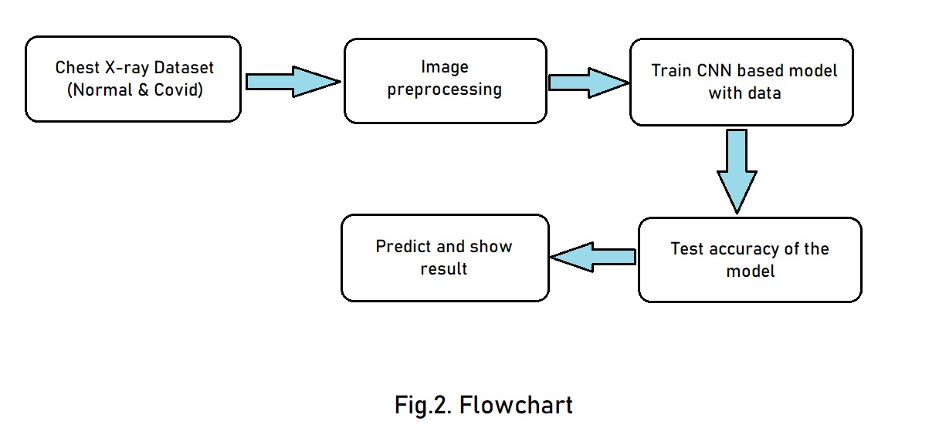

Fig. 2 Flow diagram of proposed method

Here we use CNN approach to find Covid-19 using chest X-ray. Convolutional Neural Networks is a kind of deep learning model that are commonly used for image classification. A CNN is built to systematically learn spatial levels of features from input images. The architecture of a CNN typically consists of a series of convolutional and max pooling layers, along with multiple connected layers afterwards. The convolutional layers are responsible for learning local patterns or features in the input image, such as edges, textures, and parts of objects. The max pooling layers have been used to normalize the feature maps and provide some form of translational invariance. Convolution layer to full connected layer transitions frequently use the flatten layer to reduce the multidimensional input to one dimension. The fully connected layers at the end of the network are used for classification, the output can be binary or multiple. The training process involve back-propagation and other optimization technique to adjust the parameters of the model (weights and biases) such that the classification error is minimized.

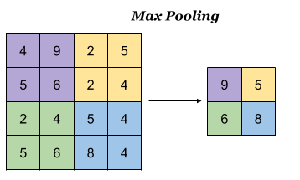

Fig. 3 Max Pooling Layer

We built a 16-layer sequential CNN architecture in the following fashion 2 convolutional layer, a max pooling layer (output shape (None, 110, 110, 64)) and a dropout layer (output shape (None, 110, 110, 64)). Again, a convolutional layer, a max pooling layer (output shape (None, 54, 54, 64)) and a dropout layer. Next, a convolutional, a max pooling, a dropout layer and a flatten layer are added. To finally categorise the photos as positive or negative for Covid-19, a fully connected dense layer is applied.

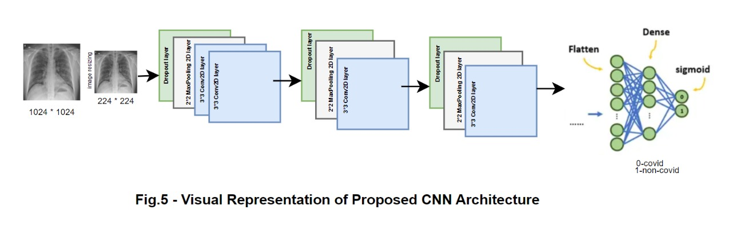

Fig. 4 Visual representation of proposed CNN model.

In our model we get the model summary as total params: 5,668,097, Trainable params: 5,668,097 and Non-trainable params: 0"Total params" refers to the total number of parameters in the model, and "Trainable params" refers to the number of parameters that can be updated during training, such as the weights and biases of neural network layers. "Non-trainable params" refers to any parameters that cannot be updated during training.

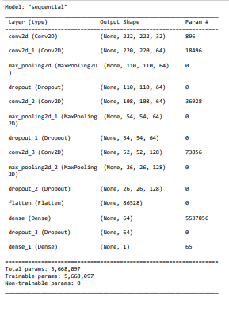

Fig. 5 Model summary

**Experiment and result**

All coding was carried out with Jupiter software on a system having 16gb ram, i5-9300h processor and GTX 1650 (4gb) GPU. The chest X-ray images are download from Kaggle and loaded into local system. Two different datasets are used to train and test the model e.g. a small dataset containing a total of 224 images including 112 Covid-19 positive X-ray images and a large dataset containing a total of 4626 including 2313 Covid-19 positive images. After 10 epoch we got train accuracy of 98% and validation accuracy of 94%.

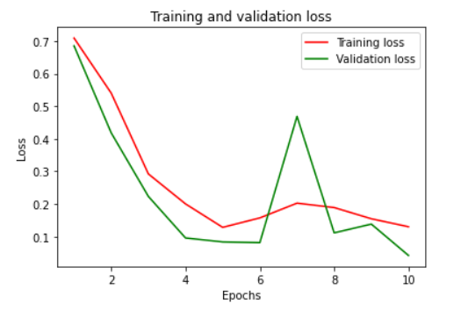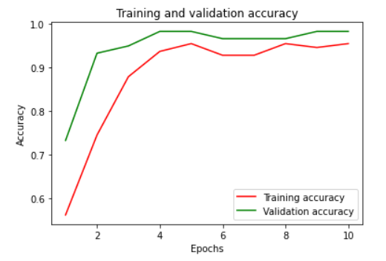

Fig. 6 & 7 loss and accuracy graph.

The examples in a predicted class are represented by each row in the confusion matrix, while the instances in an actual class are represented by each column (or vice versa). The diagonal elements of the matrix represent the number of instances that have been classified correctly, while the off-diagonal elements are the ones that have been misclassified. The entries in the diagonal are true positive, the entries outside the diagonal are false positive and false negatives, depending the position in the matrix.

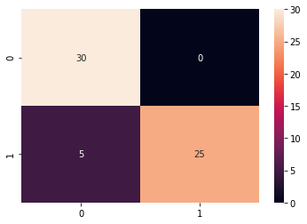

Fig. 8 Confusion matrix

We have tested our model with 60 test chest x ray images. Within those images, our model has predicted 30 Covid-19 positive images as Covid-19 positive, 5 normal images as Covid-19 positive and 25 normal images as normal.

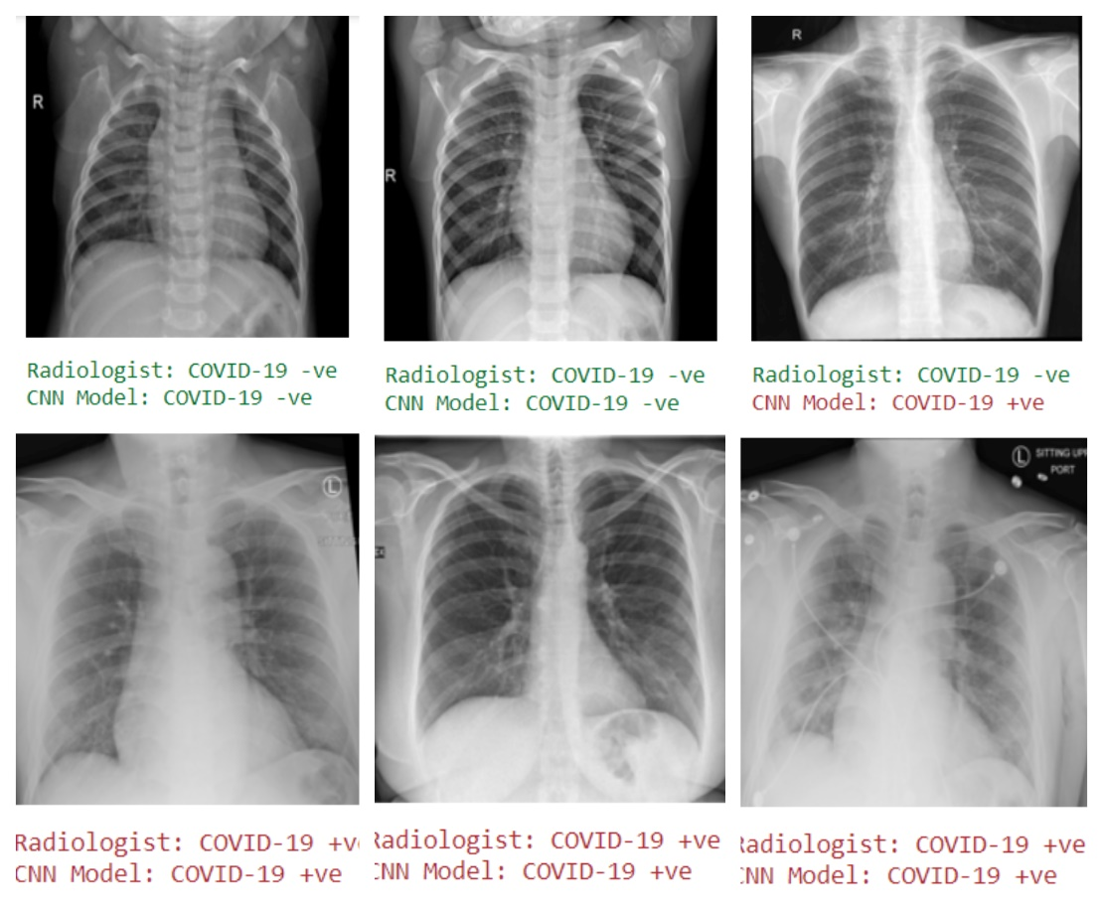

Fig.9. Test result

**Conclusion**

To stop the novel coronavirus from infecting other people, it is crucial to diagnose the virus as soon as possible. Additionally, we developed a deep transfer learning-based system that combines chest X-ray pictures of patients with COVID-19 and those without the condition to automatically identify the illness. The proposed classification model can identify COVID-19 with an accuracy of around 94 percent. Our study's findings indicate that, given its strong overall performance, doctors and other health professionals should naturally rely on it to aid in clinical decision-making. This work has a thorough grasp of the application of deep transfer learning algorithms to find COVID-19 as soon as feasible. COVID-19 kills millions of individuals and poses a threat to the global medical community. Doctors have limited time because of the enormous number of patients they encounter in emergency situations or outside, and AI-based analysis might save lives by early screening and providing the right therapy. Our refined models perform well in the categorization of COVID-19 pneumonia thanks to quick training using a limited picture set. The suggested computer-aided diagnosis technique, in our opinion, has the potential to significantly enhance COVID-19 case diagnosis. When there is a pandemic and there is a need for preventative measures but there are not enough medical resources to handle the demand, this is extremely beneficial.

**Acknowledgement**

We would like to express our sincere gratitude to our guide Dr. Chandra Mouliswaran S for his invaluable guidance and support throughout the research process. We are also deeply grateful to our Head of the Department Dr. Vanitha M for her support and guidance with the paper. We are thankful to all of our Vellore Institute of Technology (Vellore) Officials for supporting us and help us in gaining knowledge towards this research work.

**References**

Aras M. Ismael, Abdulkadir Sengur “Deep learning approaches for COVID-19 detection based on chest X-ray images”, Expert Systems with Applications,Vol 164,pp. 01-02-2021.

G. Gilanie, U.I. Bajwa, M.M. Waraich, M.M. Asghar, R. Kousar, A. Kashif, R.S. Aslam, M.M. Qasim, H. Rafique, “Coronavirus (COVID-19) Detection from Chest Radiology Images using Convolutional Neural Networks”, Biomedical Signal Processing and Control,Vol. 66, Issue.102490, pp. 1- 6,2021.

Harsh Panwar, P.K. Guptaa, Mohammad Khubeb Siddiqui, Ruben Morales-Menendez, Prakhar Bhardwaj, Vaishnavi Singha “A deep learning and grad-CAM based color visualization approach for fast detection of COVID-19 cases using chest X-ray and CT- Scan images”,ELSEVIER, Vol 140, November 2020.

Md. I. Khattak, M. Al-Hasan, A. Jan, N. Saleem, E. Verdu, N. Khurshid, “Automated Detection of COVID-19 using ChestXRay Images and CT Scans through Multilayer Spatial Convolutional Neural Networks”, International Journal of Interactive Multimedia and Artificial Intelligence, Vol.6, Issue.6, pp.15-24,2021.

Somenath Chakraborty, Beddhu Murali and Amal K. Mitra “An Efficient Deep Learning Model to Detect COVID-19 Using Chest X-ray Images”,International Journal of Environmental Research and Public Health, pp. 11 Feb 2022.

T. Rahman, A. Khandakar, Y. Qiblawey, A.Tahir, S. Kiranyaz, S.B.A. Kashem, Md.T. Islam, S.A. Madeed, S.M. Zughaier, Md. S. Khan, Md. E.H. Chowdhury, “Exploring the Effect of Image Enhancement Techniques on COVID-19 Detection Using Chest X-Ray Images", Computers in Biology and Medicine, Vol.132, Issue.104319, pp. 1-16, 2021.

T. Ozturk, Md. Talo, E.A. Yildirim, U.B. Baloglu, O. Yildirim, U. R. Acharya, “Automated Detection Of COVID-19 Cases Using Deep Neural Networks with X-Ray Images”, Computers in Biology and Medicine, Vol. 121, Issue. 103792, pp.1-11, 2020.

Vishu Madaan, Aditya Roy, Charu Gupta, Prateek Agrawal, Anand Sharma, Cristian Bologa, Radu Prodan “XCOVNet: Chest X‑ray Image Classifcation for COVID‑19 Early Detection Using Convolutional Neural Networks”, New Generation Computing, pp. 24 February 2021.